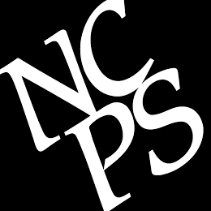
New Canaan Public Schools
39 Locust Avenue
New Canaan, CT 06840
For Immediate Release:

New Canaan High School Choir performs at Carnegie Hall

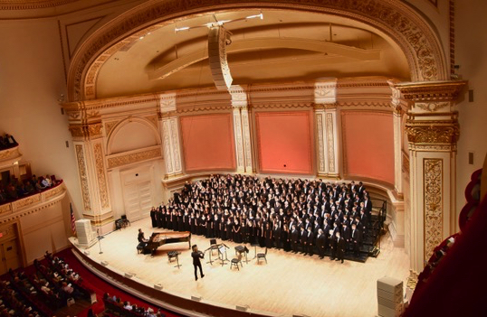
NCHS Choir joins an international student chorus in Carnegie Hall appearance

New Canaan, CT (June 26, 2019). How do you get to Carnegie Hall? Just ask the New Canaan High School Concert Choir and Madrigal Ensemble. Twenty-six members of the NCHS choir students performed The Music of Eric Whitacre in the Isaac Stern Auditorium at Carnegie Hall under the baton of Grammy-award winning Composer/Conductor Eric Whitacre in April this year. NCHS’s student musicians joined an auditioned chorus from around the world to rehearse and perform with Mr. Whitacre, who served as clinician for the 3-day residency presented by Distinguished Concerts International New York (DCINY).

“We learned 15 pieces during this year from memory and then traveled to New York City the weekend of April 26. We rehearsed on Friday and Saturday and performed at Carnegie Hall on Sunday,” explained Sarah Gleason, NCHS Choral Director.

The students appreciated the Carnegie Hall performance as a valuable learning experience. “I think that getting to do things like this really benefit students interested in music, because it lets us learn how talented musicians and composers work and see what is possible for us in the future,” said Julia Lamoreaux, NCHS sophomore, soprano. “The experience at Carnegie Hall was one of the highlights of my year and it only got better as it went along,” added Jackson Jakovic, NCHS junior, tenor. “This opportunity was wonderful for the NCHS choir because it allowed for a once in a lifetime experience working with an established composer with a diverse group of individuals in a prestigious and special location.”

The NCHS student were invited to participate “because of the quality and high level of musicianship demonstrated by the singers as well as the exceptional quality of their audition recording” wrote Dr. Jonathan Griffith, Artistic Director and Principal Conductor for DCINY in the performance invitation.

MEDIA CONTACT: Michael Horyczun
Director of Communications, New Canaan Public Schools
mike.horyczun@ncps-k12.org
office: (203) 594-4783, cell: (203) 970-2133.
# # # # #

